Dynamode USB-SOUNDCARD2.0 USB 2.0 Sound Card
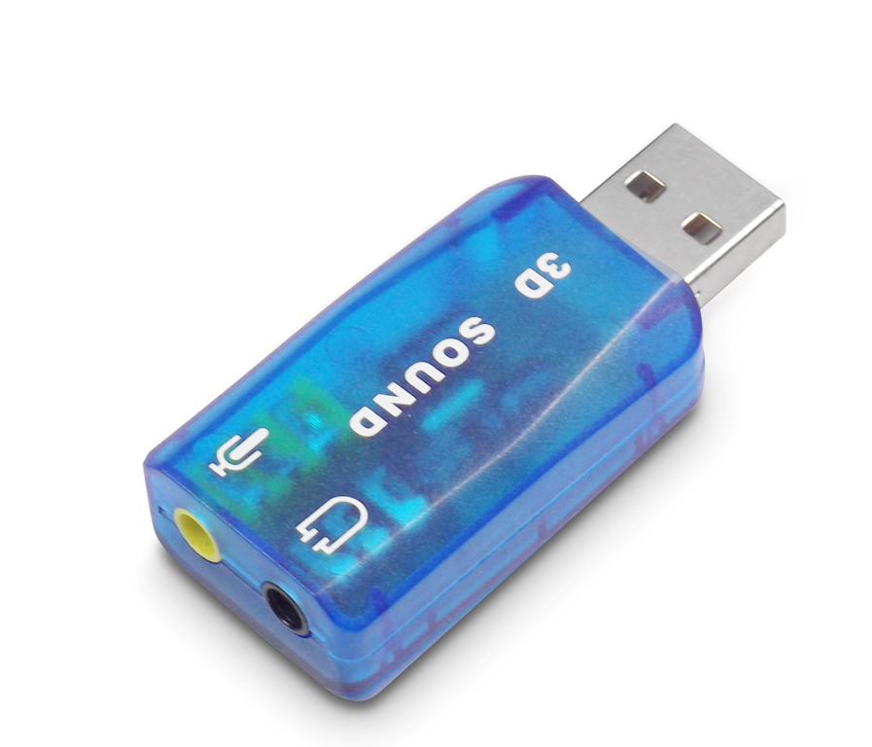

About this item
- Plug n’ Play USB interface – installs in seconds
- Transform analogue sound to digital signal
- Built-in digital Class B amplifier
- Compact and stylish design – ideal for Notebooks
- Ideal for Games, DVD entertainment and businesses

Technical Details
Brand | ‎Dynamode
Product Dimensions | ‎1.27 x 2.54 x 5.59 cm; 10 Grams
Item model number | ‎USB-SOUNDCARD2.0
Manufacturer | ‎Dynamode
Series | ‎USB-SOUNDCARD2.0
Color | ‎Blue
Hardware Platform | ‎Headphones, PC, Gaming Consoles, Laptops, Speakers
Are Batteries Included | ‎No
Item Weight | ‎10 g

